

Medjetco Integration to SAP

Business Blueprint Documentation For
HMMP Limited

Version: 1.1
Date: 18/05/2016

Revision History

Ver. # | Date | Prepared By | Significant Changes | Reviewed By
1.0 | 6/5/2016 | Yvaine Kong | Initial Document | Nick Tapang
Table of Content
1. Change Request 4
1.1 Company Code does not exist in Master Data (SO/AR/AR(P)/PO/AP) 4
1.2 Reversal Entry should be made even if clinic code changed in AP file 4
1.3 Invoice Description in A/R invoice created for Fee For Service 4
1.4 Write off of aged unbilled invoices 4
1.5 Add file name column 5
1.6 Fine Tuning the group by logic in creating journal entry and invoices 5
1.7 Customer type change 8
Acknowledgement 9

1. Change Request

Company Code does not exist in Master Data (SO/AR/AR(P)/PO/AP)
- Should the company code does not exist in master data to determine whether it is Fee For Service or Capitation, the program should not throw error and continue processing assuming the company code is Fee For Service type.
- Apply to all files SO, AR, AR(P), PO and AP

Reversal Entry should be made even if clinic code changed in AP file
- The clinic code may change in AP file with same invoice/voucher number, reversal entry should be made as long as accrual has been made based on the same invoice/voucher number, regardless the clinic code.

Invoice Description in A/R invoice created for Fee For Service
- Invoice description should be overwritten with "Consultation fee for <incurred month> <year of the incurred month>". For example: Consultation fee for May 2016
- This apply to Non Capitation, Non TPA case

Write off of aged unbilled invoices
- Accrual entries are made when users upload PO and SO file. Some of the invoices may never be billed and they need to be written off by reversing the accrual entries.
- Non TPA and Capitation transactions are uploaded in SO file but no accrual entry will be made. These transactions will not be billed. These invoices have to be set to ‘closed’ immediately after they are uploaded in SO file.
- There are 4 types of accrual from SO file
- Non TPA & Non Cap – Accrual of fee for service income
- TPA & Cap – Accrual of reimbursement cost to patient
- TPA & Non Cap – Accrual of TPA claim from insurer on behalf of patient
- TPA & Non Cap – Accrual of TPA reimbursement to patient after claim from insurer
- In order to get the open invoices for above 4 accruals, there will be 4 queries created with date range filter which allow users to export into excel file and re-upload to interface program in same format to do the reversal and close the invoices.
- For (a) accrual, users required to put the data in new file with naming convention “MS007_AR_yyyymmdd_Writeoff”
Query: Link @AE_MS007_SO to @AE_SOACCRUAL which AR status = ‘O’ with date range parameter
- For (b) accrual, users required to put the data in new file with naming convention “MS007_AR(P)_yyyymmdd_Writeoff”
Query: Link @AE_MS007_SO to @AE_COSTACCRUAL which AP status = ‘O’ with date range parameter
- For (c) accrual, users required to put the data in new file with naming convention “MS007_AR_yyyymmdd_ Writeoff”
Query: Link @AE_MS007_SO to @AE_COSTACCRUAL which AR status = ‘O’ with date range parameter
- For (d) accrual, users required to put the data in new file with naming convention “MS007_AR(P)_yyyymmdd_Writeoff”
Query: Link @AE_MS007_SO to @AE_COSTACCRUAL which AP status = ‘O’ with date range parameter
The original status column in COSTACCRUAL is used for AP status, original status column in SOACCRUAL is used for AR status. For COSTACCRUAL table, need to create new status column for AR status
- There are 2 types of accrual from PO file
- Non Capitation
- Capitation
- In order to get the open invoices for above 2 accruals, there will be 2 queries created with date range filter which allow users to export into excel file and re-upload to interface program to do the reversal.
- For both (a) and (b) accrual, users required to put the data in new file with naming convention “MS002_AP_yyyymmdd_Writeoff”
Query:
Link @AE_MS002_PO to @AE_COSTACCRUAL which AP status = ‘O’ and Type = ‘CAPITATION’ with date range parameter
Link @AE_MS002_PO to @AE_COSTACCRUAL which AP status = ‘O’ and Type <>‘CAPITATION’ with date range parameter
- Three additional tables will be created to maintain the write off transactions uploaded. These tables will capture all the transactions in the excel files.
- AE_MS007_AR_Writeoff
- AE_MS007_AR(P)_Writeoff
- AE_MS002_AP_Writeoff
- In order to ensure data integrity, MBMS, customer type, and amount which the writeoff reversal entry will use is based on the initial accrual. In short, the program only read invoice number from the write-off excel file but not any other data in other columns.
For example, accrual entry made for invoice #123 has MBMS AXA, amount $100, and this customer belongs to CAPITATION. Later users change the customer type to Fee For Service in SAP. When this invoice needs to be written off, users shall upload this invoice in writeoff file and the program should reverse based on the original data when the invoice was accrued previously.
- The reversal entry date will be extracted from the write-off excel file name.
- Reversal entry will be based on the latest GL account setting. For eg: if the accrual was made to “Fee for Service” account, later users updated the GL account setting to “Fee for Service 2” which is a newly created GL account, the reversal will take “Fee for Service 2” account.
- Make use of existing AP, AR and AR(P) program but avoid the invoice creation and the data will be uploaded into new table for eg “@AE_MS007_AR_Writeoff”

Add file name column
- “U_FileName” column will be added to below tables for reconciliation
- @AE_MS002_PO, @AE_MS002_AP, @AE_MS007_SO, @AE_MS007_AR, @AE_MS007_AR(P)_Writeoff, @AE_MS007_AR_Writeoff, @AE_MS002_AP_Writeoff

Fine Tuning the group by logic in creating journal entry and invoices
- MS007 SO

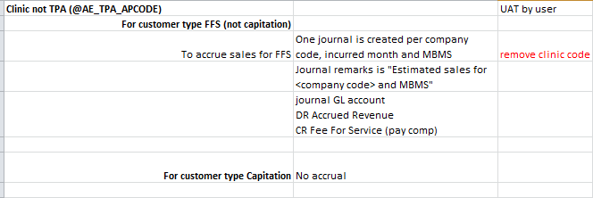
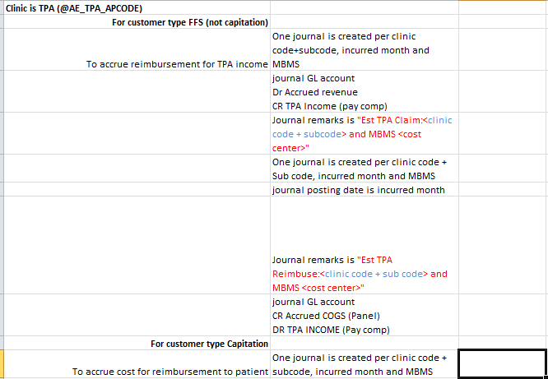

- MS007 AR
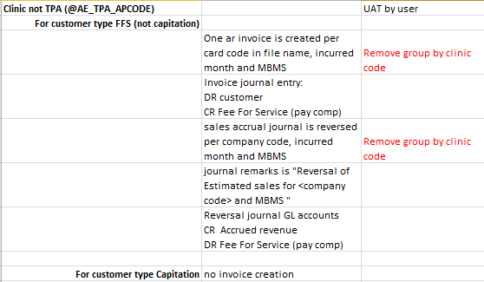
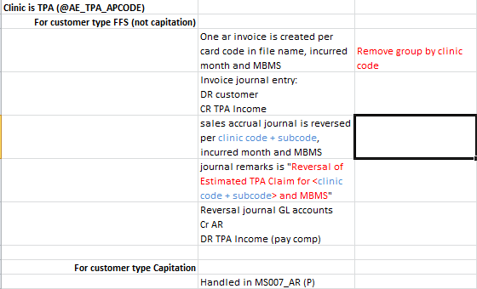
- MS007 AR(P)
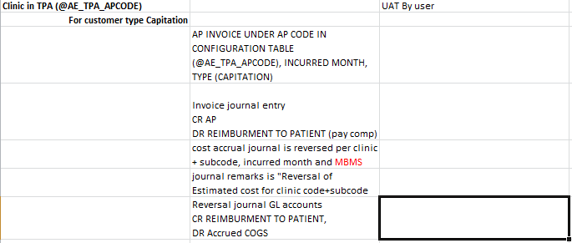
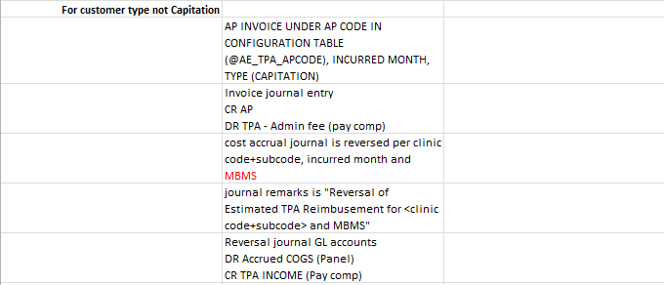

Customer type change
- If customer type change when uploading AR, AR(P), AR_Writeoff, AR(P)_Writeoff, AP, AP_Writeoff, the invoice creation should use the new customer type, but the reversal of the accrual should follow the original customer type when the accrual was made.
- Use the customer type column in SOACCRUAL and COSTACCRUAL table when do reversal

Acknowledgement

By signing this page, HMMP Limited acknowledges that this document accurately represents the requirement of HMMP Limited and that this document is the base for the changes to Medjetco integration into SAP.
Name | Department | Signature | Date

For and on behalf of Confirmed and Agreed by:
Abeo International Pte Ltd HMMP Limited

_________________________________ _________________________________
Authorized Signature & Company Stamp Authorized Signature & Company Stamp

Name: Yvaine Kong Name: Olive Yeung
________________________________ ________________________________

Title: B1 Consultant Title: Project Manager
________________________________ ________________________________

Date: 11/05/2016 Date:
________________________________ ________________________________

